

A_)

Reasons:

1. Sense Amplifier should be connected to bitline and bitline bar between column decoder and Memory array. 322222222222222222222222222222222222222222222222

2) Data is available on BL and BL' only not on Wordline.



Ans:



Ans:



Ans: See notes



Ans: see notes



Ans: a) Each array need 2 sets of I/O line. Total 4 I/O lines (I/O1, I/O1_, I/O2, I/O2_ )

b) A page of data is defined as the number of bits when one row open.

Total 512 col or 256 col/col_ set signals opened for this circuit. So a page is

equal to 256 bits or 128 words (each word has 2 bits)

c) a. Bank decoder. 3 to 8 global decoder



d) Total 18 bits needed to be routed to each array.

Include 10 Row address bits, 7 Col address bit, one Bank select signal.

e)

f)

3) 



**Ans:** we see that there will be a voltage drop along the metal line labeled *NLAT* when the sense amplifiers fire.

If the voltage drop along the line is significant (the length of the line is very long) errors can result.

Would we make things better by using individual MOSFET’s on the bottom of each NSA

connected to sense_N? Why or why not?

**Ans:** No, we would not make things better by using individual MOSFETS’s on the bottom of each NSA. We would still have the same problem, only it will be shifted to the metal line that is connected to ground instead of the NLAT line. Even worse, the layout size has now increased due to the extra transistors. 



The Following static column decoder consists of 6 Nand gates and inverters that can be

implemented to decode the desired address for figure 16.73. The outputs of the decoder

are connected to the gates of the I/O lines.





4

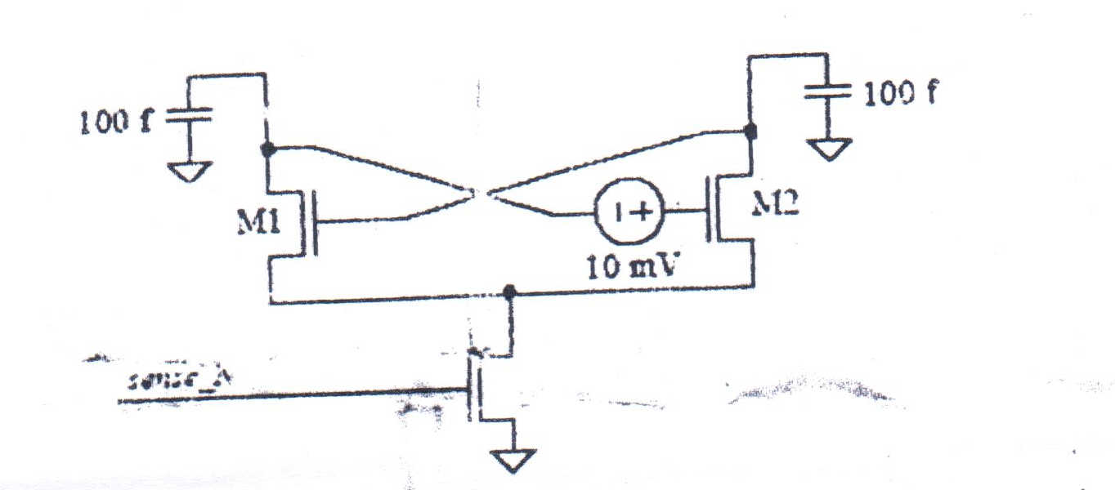



AnsBefore turning sense_N signal both the drains of M1 (100fF capacitor) and M2 (100fF capacitor)

are charged to 0.5v.When sense_N is turned ON both M1 and M2 starts conducting. Since the

voltage required on drain of M1 to turn on M2 is 10mv less than the voltage required to turn on

M1.Therefor M1 turns off faster than M2 making M2 in ON state for more time pulling the drain

voltage of M2 to ground.Therefore M2’s capacitor will fully discharge to ground.



To calculate the voltage difference on capacitor in order to cause metastability, discharge times

for both M1 and M2 should be equal

Discharge time of M1 is approximated to Tdis =CVd/Id

Where Vd is drain voltage, C is the capacitance and Id is drain current

Tdism1=100*Xm1/Id1 ; Id1(short channel current)= *V*sat1 .W1.Cox’1.(Vgs1-Vthn1-Vdsat1)

where Xm1 is voltage across the 100fF capacitor on M1in order to cause metastability.

Discharge time of M2 is approximated to Tdis =CVd/Id

Tdism2=100*0.5/Id2; Id2(short channel current )= *V*sat2 .W2.Cox’2.(Vgs2-Vthn2-Vdsat2)

Therefore Tdism1=Tdism2

From the circuit

100*Xm1/(Vgs1-Vthn1-Vdsat1) = 120*0.5/(Vgs2-Vthn2-Vdsat2);

Where Vgs2 = Xm1+10mv, Vthn=280mv and Vdsat=50mv

Solving the equation gives Xm1=0.492

Therefore voltage difference to create metastabilty=0.5-0.492 = 8mv.

Simulation shown for Xm1=0.4895v , where as calculated value for Xm1= 0.492v

Voltage difference to create metastabilty using simulation is =0.5-0.4895 = 10.5mv

